Pouria Bahrami Ataabadi

Final Report of Project 2020-366 : Estudo numérico e experimental do impacto lateral em componentes feitos de material composto

Final Report of Postdoctoral Program submitted to the Department of Mechatronics and Mechanical Systems Engineering of the Polytechnic School of the University of São Paulo.

Period: 01/06/2020 to 04/06/2025

Supervisor: Prof. Dr. Marcilio Alves

São Paulo

2025

List of contents

Contents

1. Summary of the report 3

2. Project Execution and Advancements 4

2.1 Project Execution and Advancements: 2020-2021 4

2.1.2 The scope of the study:2020-2021 4

2.1.3 Concluded activities and achievements 5

2.2 Project Execution and Advancements: 2021-2022 6

2.2.1 The scope of the study: 2022-2023 6

2.2.2 Concluded activities and achievements 7

2.3 Project Execution and Advancements: 2022-2023 7

2.3.1 The scope of the study: 2022-2023 8

2.3.2 Concluded activities and achievements 8

2.4 Project Execution and Advancements: 2023-2024 9

2.4.1 The scope of the study: 2023-2024 9

2.4.2 Concluded activities and achievements 10

2.5 Project Execution and Advancements: 2024-2025 10

2.5.1 The scope of the study: 2024-2025 11

2.5.2 Concluded activities and achievements 13

3. List of publications, conference presentations, and other activities 14

3.1 Published work 14

3.2 Under review 14

3.3 Other activities 14

References 15

Appendix 15

# Summary of the report

Project 2020-366 was conceived with a primary focus on evaluating the impact performance of panels composed of carbon fiber reinforced polymers (CFRP) and aluminum alloys, in the context of aerospace safety certification testing. The overarching objective was to reestablish the experimental capabilities of the GMSIE Laboratory, enabling it to conduct ballistic impact tests at high velocities, up to 500 km/h, through both experimental and numerical approaches. In addition to this central goal, the project also encompassed a range of experimental activities, including collaborations with industrial partners and the preparation and execution of tests supporting academic disciplines overseen by the project supervisor. While the initial phases of the project began shortly after the completion of the candidate's doctoral studies, its formal initiation was delayed until June 1, 2020, primarily due to the COVID-19 pandemic and the urgent reallocation of resources to other time-sensitive investigations. The nationwide lockdown and restricted laboratory access until mid-2021 significantly impacted experimental operations. Consequently, the early stages of the project prioritized the development of advanced numerical models to simulate CFRP material behavior under impact loading conditions. Throughout its successive extensions, the project expanded its scope to include various additional activities, such as high-strain-rate material characterization (for both metallic and polymeric materials), crashworthy design of tubular energy-absorbing structures, and dynamic friction characterization of polymeric and non-polymeric materials. The postdoctoral researcher was solely responsible for coordinating and executing all experimental tasks and general operations within the GMSIE Laboratory throughout the project’s duration.

Keywords: Crashworthiness; Ballistic impact tests; Impact Safety; Numerical simulations; Experimental method.

Note: Partial reports for each academic year, published papers, material characterization data (in Excel format), and additional documentation are available in the online repository:

<https://github.com/POUBAHdfdf/PostDoc2020-2025.git>

|  |  |
| --- | --- |
| Period | Major completed Activities |
| 2020-2021 | * Preliminary experimental tests, Ballistic test with modifying SHPB apparatus * Developing 2D VUMA subroutine for composite material in Abaqus * 1st paper published * Preparing the second paper * Initial studies regarding material characterization of polymeric materials at low temp * Prepared a tutorial for the course PMR5026 – Linear Finite Elements: Theory, Programming, and Experimentation (responsible for the course: Prof. Dr. Marcilio Alves). * Delivered an instructional session on the use of Abaqus software (PMR5026- online). |
| 2021-2022 | * The ballistic test setup, post-impact leakage tests, was fully prepared. The CFRP and aluminum plates used to complete the project were supplied by Embraer. * Project Braskem was completed (material characterization and impact testing on the railway sleepers) * A numerical model for helmet impact safety was developed and successfully validated using experimental test data. * 2nd paper based on the VUMAT material model for impact on CFRP composite components was revised and published |
| 2022-2023 | * A total of 21 ballistic tests were completed final report was delivered to Embraer. * Additional ballistic impact tests were performed on aluminum plates, and a numerical model for ballistic testing was developed using the Abaqus finite element package. A paper based on these results was prepared. * A manuscript based on the Braskem project data was submitted for publication. * The SAFE project was concluded in collaboration with Prof. Tita’s laboratory at USP São Carlos. * Two conference papers were presented at Mecsol 2022: one focused on material characterization of polymeric sleepers, and the other on structural health monitoring from the SAFE project. |
| 2023-2024 | * Three papers were revised and subsequently published in international peer-reviewed journals (3rd, 4th, and 5th papers). * Reports on the friction test study and material characterization activities conducted for SENA and IPT reports were completed and delivered. |
| 2024-2025 | * + One paper has been published based on material characterization tests conducted on additively manufactured (AM) titanium alloys [1].   + One manuscript has been submitted to Polymer Composites, focusing on the effects of hygrothermal aging and elevated temperature on the axial impact behavior of CFRP tubes.   + A study on low-velocity impact (LVI) tests and the post-impact three-point bending response of CFRP/Nomex sandwich panels was presented at Mecsol 2024.   + Approximately 90% of the material characterization tests for HX700 and ZStE 380 steels have been completed. VI. A 3D stress-state VUMAT material model for plain weave composites has been developed; however, further modifications and improvements are required. |

# Project Execution and Advancements

## Project Execution and Advancements: 2020-2021

This research project aimed to investigate the lateral impact resistance of metallic and non-metallic structural components. Motivated by the aerospace industry's growing demand for lighter and more fuel-efficient vehicles, the study addressed the critical challenge of impact-induced damage, which can severely compromise structural integrity and passenger safety. The project combined experimental investigations with finite element simulations to evaluate both low- and high-speed lateral impacts on flat and curved geometries. The experimental campaign included ballistic impact tests using projectiles of varying shapes, such as spherical and cubical impactors, to more accurately replicate realistic damage scenarios commonly encountered in aerospace applications.

On the numerical side, advanced finite element models were developed, incorporating Progressive Failure Analysis (PFA) with Hashin criteria for in-plane failure modes and Cohesive Zone Models (CZM) for delamination. Both shell- and solid-element modeling approaches were considered, and a custom user-defined material subroutine (VUMAT) was implemented to enable enhanced damage prediction via numerical models.

All experiments and simulations were conducted at the GMSIE Laboratory, which is equipped with a 50 kJ drop-weight impact tower, high-speed imaging systems, and a variety of static and dynamic testing machines. Although ballistic tests had previously been performed at GMSIE, a new gas-gun setup had to be developed to restore the laboratory’s capability to launch orientation-controlled projectiles with high precision.

### 2.1.2 The scope of the study:2020-2021

* Preliminary experimental tests, Ballistic test

1. Conducted a preliminary study and comprehensive literature review to assess the feasibility of launching non-spherical projectiles with minimal deviation from the intended impact angles.
2. Temporarily modified the Split Hopkinson Pressure Bar (SHPB) system at GMSIE to function as a short gas-gun setup, enabling ballistic testing with cubical projectiles.
3. Applied theoretical design methods to estimate key parameters for a new gas-gun system, including the optimal barrel dimensions (diameter and length), a redesigned safety enclosure, and the development of specialized sabots to accommodate cubical projectiles in various orientations (face, edge, and corner).
4. Developed and implemented techniques for accurately measuring projectile velocity and impact angles to ensure experimental precision.

* Finite Element Modeling and Progressive Failure Analysis (PFA)

1. Developed user-defined material subroutines (VUMAT) to implement advanced failure models, aiming to enhance the accuracy of simulations involving composite components.
2. Conducted comparative analyses between simulations using Abaqus’ built-in material models and those employing the custom VUMAT subroutine.
3. Performed comparative studies between two-dimensional shell-element models and three-dimensional solid-element models to evaluate their predictive capabilities and computational efficiency.

Due to limited access to the laboratory and equipment, only a small number of preliminary ballistic tests could be conducted during this phase. The main contribution of this period, therefore, was the development of numerical models and the validation of finite element simulations using impact test data on CFRP tubes obtained by the researcher during his doctoral studies.

### 2.1.3 Concluded activities and achievements

* Experimental part

1. A new gas-gun system was developed at the GMSIE Laboratory, featuring an optimized barrel design and a dedicated plate target fixture, enabling the launch of small projectiles at velocities of up to 270 m/s.
2. Continuous testing and refinement were conducted to enable the launch of cubical projectiles at controlled impact angles with minimal deviation, under Embraer’s specific requirements.
3. Techniques were developed for accurately measuring projectile velocity and impact angles in two distinct orientations to ensure test precision.

* Numerical part

1. A numerical study was prepared and published using Abaqus’ built-in material model for composite materials to investigate the impact response of CFRP tubes. The results were published in the journal *Polymer Composites* [2].
2. A VUMAT-based material model was developed for shell elements (S4R) to simulate the impact response of composite components under dynamic loading conditions. The corresponding study was prepared and submitted as a paper to the Composite Structures Journal [3].

* Other completed activities

1. Prepared a tutorial for the course PMR5026 – Linear Finite Elements: Theory, Programming, and Experimentation (responsible for the course: Prof. Dr. Marcilio Alves).
2. Delivered a 2.5-hour instructional session on the use of Abaqus software (PMR5026).
3. Contributed to the planning of material characterization tests for polymeric materials intended for the production of railroad sleepers.

## Project Execution and Advancements: 2021-2022

One of the most technically demanding challenges of the project was the high-speed launch of cubical projectiles with controlled impact orientation. The goal was to strike composite target plates at predefined angles, specifically Edge-on, Corner-on, and Face-on configurations. This requirement posed significant complexity, as cubical projectiles are highly sensitive to rotational instability and angular deviation during flight. To address this, numerous SABOT designs were developed and fabricated using 3D printing, each iteratively refined based on performance in successive trial tests. These preliminary ballistic tests were essential for calibrating the launch parameters and establishing a reliable methodology that met the strict alignment criteria demanded by the application. Achieving repeatable and accurate projectile orientation at high velocities represented a significant technical milestone in the project. In parallel with the core research activities, two additional investigations were integrated into the project during the 2021–2022 period. The first focused on the material characterization of polymeric materials at low temperatures, which was essential for evaluating their mechanical behavior under cold-service conditions, particularly relevant for components such as railway sleepers. The second involved a combined numerical and experimental study aimed at assessing the protective performance of safety helmets under impact loading.

### 2.2.1 The scope of the study: 2021-20222

* Experimental ballistic tests with cubical projectiles

1. Develop three optimized SABOT designs for Face-on, Corner-on, and Edge-on ballistic impact tests.
2. Calibrate the gas-gun system to conduct tests at controlled velocities ranging from 215 m/s to 225 m/s.

* Material characterization and impact testing on polymeric railway sleepers in collaboration with Braskem.

1. Perform quasi-static and dynamic (Split Hopkinson Pressure Bar) tests at both room temperature and –30 °C.
2. Conduct low-velocity impact tests at room temperature and –30 °C on the assembled rail track and composite sleeper using a drop-weight impact rig.

* Continue the ongoing study on the safety performance of Brazilian helmets[1].

1. Develop a numerical model in Abaqus for simulating impact tests on helmets, using 3D helmet geometries generated through Structure-from-Motion (SfM) photogrammetry with Agisoft Metashape software.
2. Prepare the helmet test rig at the GMSIE Laboratory and conduct experimental impact tests on helmet specimens.
3. Validate the numerical model by comparing simulation results with experimental test data.

### 2.2.2 Concluded activities and achievements

* The manuscript based on the VUMAT material model for impact on CFRP composite components was revised and subsequently published [3].
* The ballistic test setup, along with all associated requirements for conducting official impact and post-impact leakage tests, was fully prepared. The CFRP and aluminum plates used to complete the project were supplied by Embraer.
* Material characterization and impact testing on the railway sleepers for the Braskem project were completed, and the final report was delivered.
* A numerical model for helmet impact safety was developed and successfully validated using experimental test data.

## Project Execution and Advancements: 2022-2023

In the past period of the project, a new gas gun was developed, and the necessary SABOTs for carrying cubical projectiles were designed and 3D-printed through a demanding experimental trial-and-error process. CFRP and aluminum targets were provided by Embraer, and all preparations were completed to finalize the ballistic tests and conduct post-impact leakage tests on the aluminum target plates. Therefore, the main objective for the 2022–2023 period was to complete the ballistic tests and deliver the final report. Other activities during this period included the preparation of publications (a conference paper and a journal article) related to material characterization and impact testing of polymeric railway sleepers (Braskem project). Additional ballistic tests were also performed on aluminum plates using both cubical and spherical projectiles, intended for an experimental–numerical publication, as Embraer did not authorize the release of the original experimental results. Moreover, a one-year collaborative study was conducted between the GMSIE laboratory and Prof. Tita’s laboratory at USP São Carlos to evaluate the performance of a battery as a sensor for structural health monitoring (SHM) and impact damage detection in CFRP beams using a vibration-based method (SAFE project).

### The scope of the study: 2022-2023

* Finalization of the ballistic impact test project for Embraer, including the execution of leakage tests following each impact.
* Conducting additional ballistic tests using spherical and cubical projectiles for an academic publication, and developing a numerical model for ballistic impact on CFRP sandwich panels and aluminum plates.
* Preparation of an academic paper based on experimental data obtained from material characterization and impact testing of polymeric sleepers.
* A collaboration was initiated with Prof. Tita’s laboratory as part of the SAFE project, which included the following activities:

1. Low-velocity impact (LVI) tests on CFRP beams with different stacking sequences;
2. Vibration testing of the beams before and after impact to compare the frequency response functions (FRFs) of damaged and pristine specimens
3. Damage quantification through the comparison of FRFs and the changes in the natural frequencies between the intact and damaged beams.

* Conducted a literature review on the characterization of dynamic friction coefficients of materials used in the automotive industry, in preparation for experimental testing in the following year of the project. Reliable friction Cof is required for improving crash simulation in the automotive industry.

### 2.3.2 Concluded activities and achievements

* A total of 21 valid tests (seven repetitions for each impact orientation: edge-on, corner-on, and face-on) were completed, along with corresponding leakage test reports. The final report was delivered to Embraer.
* Additional ballistic impact tests were performed on aluminum plates, and a numerical model for ballistic testing was developed using the Abaqus finite element package. A paper based on these results was prepared.
* A manuscript based on the Braskem project data was submitted for publication.
* The SAFE project was concluded in collaboration with Prof. Tita’s laboratory at USP São Carlos.
* Two conference papers were presented at Mecsol 2022: one focused on material characterization of polymeric sleepers, and the other on structural health monitoring from the SAFE project.

## Project Execution and Advancements: 2023-2024

The primary focus of the project in 2023–2024 pertains to Dynamic Friction Coefficient characterization as outlined in the 2022–2023 project framework. Friction between contacting surfaces plays a critical role in determining structural deformation modes and kinetic energy absorption during accidents and collisions. However, dynamic friction has not received adequate attention within the field of automotive crashworthiness. A significant gap in the availability of contact friction data for various materials, such as metallic automotive components, airbags, seat belts, dummy skins, and others, continues to undermine the accuracy and reliability of vehicle crash simulations. Accordingly, this project aims to conduct a comprehensive investigation to enhance the understanding of friction coefficient behavior across a wide range of materials used in the automotive industry. Specimens, including dummy skins, seat covers, seat belts, metallic components, and honeycomb structures, are being provided by BMW for this purpose.

In addition to the main research activity, several supplementary tasks are planned for 2023-2024, including material characterization and high-energy impact testing for external companies and research institutions.

### The scope of the study: 2023-2024

* Dynamic friction coefficient at different slip rates ( from quasi-static to 3 m/s relative velocity)

1. Planning and making designs for cutting required samples from raw materials
2. Finding more desired methods for attaching the specimens to the friction rig, preventing misalignment
3. Conducting preliminary tests for checking the rig, equipment, and instruments,
4. Performing the quasi-static friction tests (combination of different contact pressures and different slip rates)
5. Performing the high-velocity friction tests (combination of different contact pressures and different slip rates)
6. Data reduction and preparing the final report.

* Dynamic material characterization of SENAI-FIAT (TRIP and DP steel materials)

1. Design of tensile specimens for both quasi-static and high-strain-rate tensile tests
2. Execution of quasi-static tensile tests
3. Execution of high-strain-rate tensile tests using the Split Hopkinson Tensile Bar (SHTB) apparatus
4. Determination of Johnson-Cook (JC) plasticity model parameters based on experimental data
5. Preparation and submission of the final report

Note: The Split Hopkinson Tensile Bar (SHTB) apparatus must be reassembled, and a new gripping fixture for the test specimens should be designed and fabricated.

* Dynamic material characterization of specimens extracted from tubes, and low-velocity impact testing on tubular energy absorbers.

1. Design of tensile specimens for both quasi-static and high-strain-rate tensile tests from cutting circular tubes
2. Execution of quasi-static tensile tests
3. Execution of high-strain-rate tensile tests using the Split Hopkinson Tensile Bar (SHTB) apparatus
4. Determination of Johnson-Cook (JC) plasticity model parameters based on experimental data
5. Axial impact tests on the energy absorber using a drop hammer rig (up to 7 kJ impact energy)
6. Preparing report

### Concluded activities and achievements

* **Three papers were revised and subsequently published in international peer-reviewed journals.**

1. Dynamic response of polymeric railway sleepers under harsh loading and environmental conditions, International Journal of Rail Transportation (From impact tests and material characterization tests on the polymeric railway sleepers) [4].
2. High-Velocity Impact Performance of AA 7475-T7351 Aluminum Square Plates Struck by Steel Projectiles: Assessing Leakage Limit Velocity. International journal of impact engineering,2024. (From ballistic tests on the aluminum plates and post-impact leakage tests) [5]
3. Response of a novel all-solid-state sodium-based-electrolyte battery to quasi-static and dynamic stimuli. Proceedings of the Institution of Mechanical Engineers, Part L: Journal of Materials: Design and Applications (from SAFE project) [6].

* **Reports on the friction test study and material characterization activities conducted for SENA and IPT were completed and delivered.**

## Project Execution and Advancements: 2024-2025

The initial project plan for the 2024–2025 academic year was primarily focused on characterizing the friction coefficient between various material pairs under a range of contact pressures (up to 4 MPa) and slip rates (up to 3 m/s). In previous years, the GMSIE laboratory developed a friction rig and conducted empirical tests to evaluate the frictional behavior between selected soft materials (e.g., artificial skin, seat covers, airbags, and seat belts) and rigid automotive components (including high-strength plastics, aluminum, and steel). However, several experimental inconsistencies were identified in collaboration with the BMW technical team, which highlighted the need for further refinement of the testing methodology. The 2024–2025 plan initially aimed to address these challenges by improving the experimental setup, developing a new dynamic friction measurement rig, and conducting a comprehensive series of quasi-static and dynamic tests across different material pairings. Nevertheless, due to BMW’s decision to discontinue the collaboration and the consequent lack of financial support, this segment of the research was canceled. As a result, the focus for the 2024–2025 period was redirected toward an experimental investigation into the effects of thermal and hygrothermal aging on the crashworthiness of CFRP tubes with different stacking sequences.

The investigation of low-velocity and hailstone impacts on CFRP sandwich panels supplied by Embraer constituted the second major objective of the project plan. This component of the study was partially carried out during the period.

As an additional activity, a high strain rate material characterization task was assigned to the postdoctoral researcher, in which the dynamic mechanical properties of HX700 and ZSTE 380 steels, supplied by Marcopolo, were experimentally evaluated.

### The scope of the study: 2024-2025

The portion of the proposal concerning the development of a new dynamic friction measurement rig was canceled and subsequently replaced with alternative activities. The following tasks were selected to substitute the originally planned work.

* **Experimental assessment of hygrothermal thermal aging effects on the crashworthy of CRFP tubes**
* Environmental Conditioning and Material Aging
  1. Controlled exposure of CFRP laminated composite specimens to thermal and hygrothermal environments to simulate aging conditions typically encountered in service.
  2. Thermal aging is performed at elevated temperatures (e.g., 50 °C and 75 °C), while hygrothermal aging involves immersion in distilled water at controlled temperatures (e.g., 25 °C and 75 °C) over extended durations.
  3. Additional post-aging treatments (e.g., redrying) are employed to evaluate the reversibility of moisture-induced degradation.
* Axial Impact Testing of Aged CFRP Tubes
  1. Fabrication and preparation of CFRP tubes with different stacking sequences (e.g., cross-ply and angle-ply configurations).
  2. Execution of quasi-static compression and drop-weight impact tests to assess crashworthiness metrics such as energy absorption means crushing force, and specific energy absorption (SEA).
  3. Comparison between unaged, aged, and re-dried specimens to isolate the effects of moisture uptake and thermal softening on mechanical performance.
* Failure Analysis and Crash Mode Evaluation
  1. Detailed examination of failure mechanisms through post-impact inspection, including identification of macroscopic crushing modes and inter/intralaminar failure characteristics.
  2. Analysis of the influence of stacking sequence and environmental degradation on the stability and deformation patterns during axial impact loading.
* Correlation with Material Degradation Mechanisms
  1. Interpretation of results based on known matrix degradation phenomena, such as plasticization, fiber-matrix debonding, and reduced interlaminar shear resistance due to moisture diffusion and thermal exposure.
  2. Discussion of how environmental effects alter the balance between fiber-dominated and matrix-dominated failure modes.
* **LVI studies on the GFRP and CFRP/Nomex sandwich panels provided by Embraer and Hailstone impact**
* Experimental Investigation of Low-Velocity Impact (LVI) on Laminated and Sandwich Panels
  1. Preparation and characterization of laminated composite panels made of S-glass/PEKK and CFRP/Nomex honeycomb sandwich panels.
  2. Execution of low-velocity impact tests at various energy levels and impact locations (center and off-center) to assess the sensitivity of damage evolution and energy absorption mechanisms.
  3. Post-impact evaluation through residual flexural strength tests (three-point bending) on impacted sandwich panels.
* Finite Element Modeling and Development of User-Material Subroutine
  1. Construction of detailed finite element models using Abaqus/Explicit to simulate LVI events on laminated and sandwich structures.
  2. Implementation of a user-defined material subroutine (VUMAT) for the composite plies, incorporating intralaminar damage models based on stress-based failure criteria, element degradation, and deletion schemes.
  3. Modeling of interlaminar failure using a surface-based cohesive zone model to capture delamination behavior under impact.
* Validation of Numerical Models
  1. Comparison of numerical predictions with experimental results in terms of force-displacement histories, absorbed energy, permanent indentation, damage area, and failure mechanisms.
  2. Assessment of the performance and limitations of the developed numerical framework, particularly regarding the prediction of post-impact residual properties and damage morphology.
* Experimental and numerical study of hailstone impact on CFRP/Nomex sandwich panels

1. Experimental impact of ice sphere on the sandwich panels provided by Embraer using a gas gun
2. Numerical modeling of ice impact on the sandwich panel in Abaqus or Ls-Dyna.

* **Preparation of manuscripts based on the data acquired during the earlier phases of the study.**
  + 1. Preparation of a manuscript on material characterization.
    2. Preparation of a manuscript based on experimental data from the SAFE project.
    3. Preparation of a manuscript addressing the effects of hygrothermal aging and elevated temperature on the crashworthiness of CFRP tubes.

Note: In the initial phase of the project, a two-dimensional VUMAT material subroutine was developed and its accuracy was validated through numerical simulations of axial impact on CFRP laminated tubes. This same subroutine was subsequently applied to model low-velocity impact (LVI) tests on GFRP and CFRP/Nomex sandwich panels. However, the finite element model failed to accurately capture both the quantitative and qualitative aspects of the composite response under LVI conditions. To address these limitations, a three-dimensional VUMAT subroutine incorporating a non-progressive failure scheme was developed, aiming to enhance the predictive capabilities of the model. A brief description of the 3D VUMAT implementation in Abaqus is provided Appendix.

* **Material characterization and rate sensitivity assessment of HX700 and ZSTE 380 steels for Marcopolo**

1. Design of tensile specimens for both quasi-static and high-strain-rate tensile tests
2. Execution of quasi-static tensile tests (cross-head velocity: 0.0008 mm/s)
3. Execution of intermediate strain rate tests, using Impact Tensile test apparatus ( 100, 200, 500 1/s)
4. Execution of high-strain-rate tensile tests using the Split Hopkinson Tensile Bar (SHTB) apparatus (1000 1/s and 2000 1/s)
5. Determination of Johnson-Cook (JC) plasticity model parameters based on experimental data
6. Axial impact tests on the energy absorber using a drop hammer rig (designing different trigger mechanisms)
7. Preparing report

### Concluded activities and achievements

* 1. One paper has been published based on material characterization tests conducted on additively manufactured (AM) titanium alloys [1].
  2. One manuscript has been submitted to Polymer Composites, focusing on the effects of hygrothermal aging and elevated temperature on the axial impact behavior of CFRP tubes.
  3. A study on low-velocity impact (LVI) tests and the post-impact three-point bending response of CFRP/Nomex sandwich panels was presented at Mecsol 2024.
  4. Approximately 90% of the material characterization tests for HX700 and ZStE 380 steels have been completed.  
     VI. A 3D stress-state VUMAT material model for plain weave composites has been developed; however, further modifications and improvements are required.

# List of publications, conference presentations, and other activities

## Published work

List of publications co-authored by the postdoctoral researcher and the supervising professor during the project period.

Title: **Finite element modeling of CFRP composite tubes under low-velocity axial impact**

Journal: **Polymer Composites**

Authors: D.Karagiozova, (2nd) **P. B. Ataabadi, M. Alves**

Title**: Finite element modeling of crushing of CFRP cylindrical tubes under low-velocity axial impact**

Journal: **Composite Structures Journal**

Authors: **P. B. Ataabadi**, D. Karagiozova, **M. Alves**

Title**: Dynamic response of polymeric railway sleepers under harsh loading and environmental conditions**

Journal: **International Journal of Rail Transportation**

Authors: **P. B. Ataabadi**, R. Vargas, **M. Alves**

Title: **High-velocity impact performance of AA 7475-T7351 aluminum square plates struck by steel projectiles: Assessing leakage limit velocity**

Journal: **International Impact Engineering**

Authors: **P.B Ataabadi** .... **M. Alves**

Title: **Response of a novel all-solid-state sodium-based-electrolyte battery to quasi-static and dynamic stimuli**

Journal: **Proceedings of the Institution of Mechanical Engineers, Part L: Journal of Materials: Design and Applications**

Authors: B. G. Christoff, .... **(3rd author) P.B. Ataabadi**, ...... **M. Alves,** ... V. Tita

Title: **Hot Isostatic Pressing Effects on Ductile Fracture in Additive Manufactured Ti-6Al-4V Alloy: An Experimental and Numerical Approach**

Journal: **Journal of Materials Engineering and Performance**

Authors: M.H. Shaterzadeh, **(2nd author) P. B Ataabadi**, ....., **M. Alves**

## Under review works

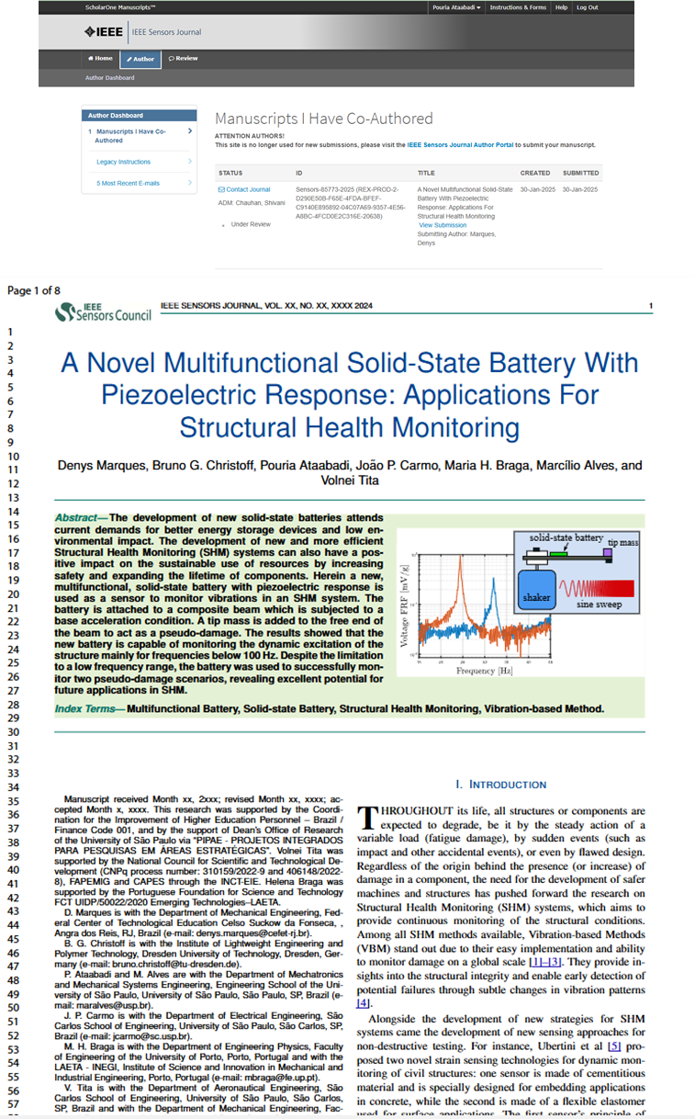

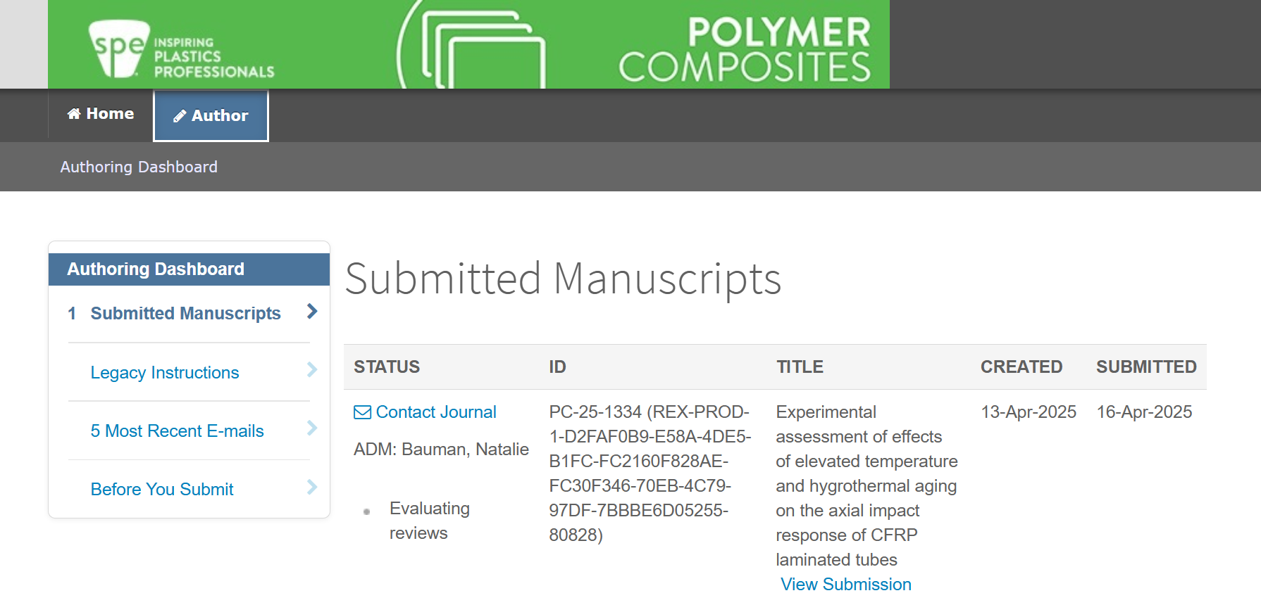

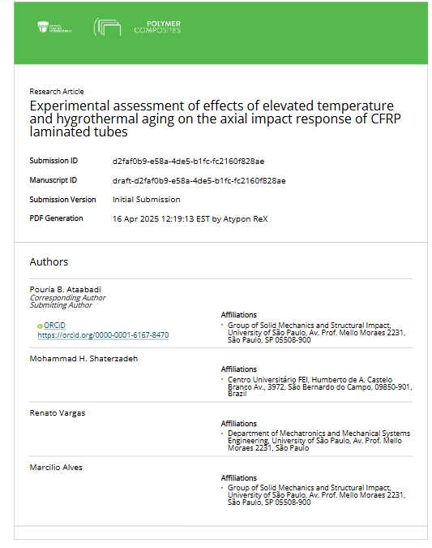

## Other activities and conference presentations

**Review for academic journals and Master’s thesis defense examination committee**

1. Performed 40 peer reviews for the Thin-Walled Structures journal.
2. Performed 52 peer reviews for the Composite Structures journal.
3. Served on the master's qualification examination committee for candidate Ana Claudia Macedo Vianna Miachon, supervised by Prof. Dr. Marcilio Alves.

Impact response of polymeric train sleepers P. Ataabadi, R. Vargas, M. Alves, 8th International Symposium on Solid Mechanics 2022

Structural Health Monitoring of Thermoplastic Composite Beams via Vibration-based Method , P. Ataabadi, D. Marques, B. Christoff, M. Leite, M. Alves, V. Tita 8th International Symposium on Solid Mechanics 2022.

### Low-velocity Impact on CFRP/Nomex Sandwich Panels, P. B Ataabadi, M Alves, 9th International Symposium on Solid Mechanics 2024.

# References

[1] M. H. Shaterzadeh, P. B. Ataabadi, L. Driemeier, and M. Alves, “Hot Isostatic Pressing Effects on Ductiles Fracture in Additive Manufactured Ti-6Al-4V Alloy: An Experimental and Numerical Approach,” *J Mater Eng Perform*, Mar. 2025, doi: 10.1007/s11665-025-10936-w.

[2] D. Karagiozova, P. B. Ataabadi, and M. Alves, “Finite element modeling of <scp>CFRP</scp> composite tubes under low velocity axial impact,” *Polym Compos*, vol. 42, no. 3, pp. 1543–1564, Mar. 2021, doi: 10.1002/pc.25923.

[3] P. B. Ataabadi, D. Karagiozova, and M. Alves, “Finite element modeling of crushing of CFRP cylindrical tubes under low-velocity axial impact,” *Compos Struct*, vol. 280, p. 114902, Jan. 2022, doi: 10.1016/j.compstruct.2021.114902.

[4] P. B. Ataabadi, R. Vargas, and M. Alves, “Dynamic response of polymeric railway sleepers under harsh loading and environmental conditions,” *International Journal of Rail Transportation*, pp. 1–19, Oct. 2023, doi: 10.1080/23248378.2023.2271507.

[5] Pouria. B. Ataabadi, C. M. de Assunção, P. Chakraborty, and M. Alves, “High-velocity impact performance of AA 7475-T7351 aluminum square plates struck by steel projectiles: Assessing leakage limit velocity,” *Int J Impact Eng*, vol. 187, p. 104913, May 2024, doi: 10.1016/j.ijimpeng.2024.104913.

[6] B. G. Christoff *et al.*, “Response of a novel all-solid-state sodium-based-electrolyte battery to quasi-static and dynamic stimuli,” *Proceedings of the Institution of Mechanical Engineers, Part L: Journal of Materials: Design and Applications*, Apr. 2024, doi: 10.1177/14644207241247732.

# Appendix

|  |
| --- |
|  |
| Numerical and experimental tests on helmets |

|  |
| --- |
|  |
| Results of 2D VUMAT developed for CFRP materials |

|  |
| --- |
|  |
| Dynamic friction test study, quasi-static, sample materials, and dynamic setup |

|  |
| --- |
|  |
| Ballistic tests |

|  |
| --- |
|  |
| LVI test and post-impact 3point bending on the CFRP/Nomex sandwich panel |

|  |
| --- |
|  |
| Effect of hygrothermal and thermal aging on crashworthiness of CFRP tubes |

**3D VUMAT for LVI tests (description of damage initiations and non-progressive failure scheme)**

A finite element (FE) model for simulating low-velocity impact on composite plates is developed using the Abaqus/Explicit commercial finite element software. The laminated composite plate is modeled by stacking multiple layers of continuum plies, allowing the simulation to capture both intralaminar and interlaminar responses during impact. This layered FE approach is designed to accurately predict the detailed mechanical behavior of composite plates under low-velocity impact conditions. The built-in surface-based cohesive model in Abaqus is employed to represent the inter-layer mechanical response.

Figure 1 illustrates the selected mechanical behavior of the composite ply. In the non-progressive damage response, the material exhibits elastic behavior (path AB) until the failure criterion is reached at point B. At this stage, the mechanical properties associated with the failure mode are instantaneously reduced to 90% of their initial values. Following this degradation, the failed element undergoes a near-complete unloading process (path BC) while remaining active in the simulation. This mechanical response is applied to composite plies in the in-plane directions (directions 1 and 2) as well as in the through-thickness direction (Z-direction) under both compressive and tensile stress conditions. To prevent excessive distortion of the failed element, an element deletion criterion is employed. Once this criterion is satisfied (point D), the failed element is removed from the simulation.

|  |  |
| --- | --- |
|  |  |
| Fig. 1. Bilinear stress-strain response of inter-layer composite ply. | |

**Intralamina response**

A three-dimensional stress state user material subroutine (VUMAT) is employed to simulate the orthotropic behavior of composite plies. The stress-strain relationship for this 3D stress state is described by Eq. 1

|  |  |
| --- | --- |
| $$\left[\begin{matrix}σ_{11} \\ σ_{22} \\ \begin{matrix}σ_{33} \\ σ_{12} \\ \begin{matrix}σ_{23} \\ σ_{13}\end{matrix}\end{matrix}\end{matrix}\right]= \left[\begin{matrix}\begin{matrix}C_{11} & C_{12} & C_{13} \\ & C_{22} & C_{23} \\ & & C_{33}\end{matrix} & \begin{matrix} & & \\ & & Zeros \\ & & \end{matrix} \\ \begin{matrix} & & \\ & Sym & \\ & & \end{matrix} & \begin{matrix}{2C}_{44} & & \\ & {2C}_{55} & \\ & & {2C}_{66}\end{matrix}\end{matrix}\right]\left[\begin{matrix}ε_{11} \\ ε_{22} \\ \begin{matrix}ε_{33} \\ ε_{12} \\ \begin{matrix}ε_{23} \\ ε_{13}\end{matrix}\end{matrix}\end{matrix}\right]$$ | (1) |

By introducing appropriate damage variables, that degrade the components of the stiffness matrix Eq.1 will represent the material's response under both intact (undamaged) and damaged conditions regarding the value of the corresponding damage variables. Consequently, the general form of the stiffness matrix components is presented in Eq. 2.

|  |  |  |
| --- | --- | --- |
| $$C_{11}= {\left(1 - d_{f}\right)C}_{11}^{0}$$ | (a) | (2) |
| $$C_{22}= {\left(1 - d_{f}\right)C}_{22}^{0}$$ | (b) |
| $$C_{33}= {\left(1 - d_{m}\right)C}_{33}^{0}$$ | (c) |
| $$C_{12}= {\left(1 - d_{f}\right)\left(1 - d_{m}\right)C}_{12}^{0}$$ | (d) |
| $$C_{23}= {\left(1 - d_{f}\right)\left(1 - d_{m}\right)C}_{23}^{0}$$ | (e) |
| $$C_{13}= {\left(1 - d_{f}\right)\left(1 - d_{m}\right)C}_{13}^{0}$$ | (f) |
| $G_{12}= {\left(1 - d_{f}\right)\left(1 - d_{mc}\right)C}_{44}^{0}$, $C_{44}^{0}$ = $G_{12}$ | (g) |
| $G_{23}= {\left(1 - d_{f}\right)\left(1 - d_{mt}\right)\left(1 - d_{mc}\right)C}_{23}^{0}$, $C_{55}^{0}$ = $G_{23}$ | (h) |
| $G_{13}= {\left(1 - d_{f}\right) \left(1 - d_{mt}\right)\left(1 - d_{mc}\right)C}_{13}^{0}$, $C_{66}^{0}$ = $G_{13}$ | (i) |

There are two types of damage variables in Eq. 2; (I) fiber dominant damage variables (*df*) and (II) matrix dominant damage variables (*dm*). In this study, the same amount of fibers are placed in two in-plane orthogonal directions of composite (1-direction and 2-direction), thus, *df1* and *df2*are fiber damage variables due to fiber failure modes in 1-direction and 2-direction, respectively. Besides fiber dominant failure modes, the composite plies can fail due to matrix damage failure modes where matrix damage variable *dm* degrades the corresponding components of stiffness matrix as expressed in Eq.2. All damage variables are defined in Eq. 3.

|  |  |  |
| --- | --- | --- |
| $$d_{f1}= 1 - \left.\left( 1 - d_{f1t}\right.\right)\left.\left( 1 - d_{f1c}\right.\right)$$ | (a) | (3) |
| $$d_{f2}= 1 - \left.\left( 1 - d_{f2t}\right.\right)\left.\left( 1 - d_{f2c}\right.\right)$$ | (b) |
| $$d_{f}=1 - \left.\left( 1 - d_{f1}\right.\right)\left.\left( 1 - d_{f2}\right.\right)$$ | (c) |
| $$d_{m}= 1 - \left.\left( 1 - d_{mt}\right.\right)\left.\left( 1 - d_{mc}\right.\right)$$ | (d) |
| Note: The subscripts *c* and *t* denote compression and tension failure modes, respectively. | | |

The initial (undamaged) components of the stiffness matrix, $C_{ij}^{0},$ in Eq. 2 are calculated using the formulas provided in Eq.4.

|  |  |  |
| --- | --- | --- |
| $$C_{11}^{0}= E_{11}\left(1 - ν_{23}ν_{32}\right)∆$$ | (a) | (4) |
| $$C_{22}^{0}= E_{22}\left(1 - ν_{13}ν_{31}\right)∆$$ | (b) |
| $$C_{33}^{0}= E_{33}\left(1 - ν_{12}ν_{21}\right)∆$$ | (c) |
| $$C_{12}^{0}= E_{11}\left(ν_{21} - ν_{31}ν_{23}\right)∆$$ | (d) |
| $$C_{13}^{0}= E_{11}\left(ν_{31} - ν_{21}ν_{32}\right)∆$$ | (e) |
| $$C_{23}^{0}= E_{22}\left(ν_{32} - ν_{12}ν_{31}\right)∆$$ | (f) |
| $$∆=\frac{1}{\left(1-ν_{21}ν_{12}-ν_{32}ν_{23}-ν_{13}ν_{31}-2ν_{13}ν_{21}ν_{32}\right)}$$ | | |

The material model incorporates six independent damage variables (*dmt*, *dmc*, *df1t*, *df1c*, *df2t*, *df2c*) under compressive and tensile loading conditions. All fiber and matrix dominant damage variables can take one of two values: (I) zero, representing the undamaged condition, and (II) a maximum value (dmax =0.90) when the damage criterion is met when a damage variable turns equal to 0.90 it will remain constant during the simulation. In other words, the material exhibits linear elastic behavior until a failure criterion is satisfied, at which point the corresponding damage variable instantaneously reaches its maximum value. Consequently, the associated components of the stiffness matrix are degraded by Eq. 2.

Six failure criteria are employed to account for intralaminar damage. As previously mentioned, for plain weave composite plies under investigation, an equal amount of fibers is present in both the 1- and 2-directions. Therefore, unlike unidirectional plies, fiber damage (due to compression and tension) is considered in both the 1- and 2-directions. Matrix failure modes under compression and tension are also taken into account to characterize damage in the out-of-plane (Z-direction). All failure modes are detailed in Eq. 5.

|  |  |  |  |
| --- | --- | --- | --- |
| Fiber failure tension in i-direction (*i*=1,2) | $$f_{ft}^{i}=\left(\frac{σ_{i}}{X_{i}^{T}}\right)+\left(\frac{τ_{12}}{S_{12}}\right)+\left(\frac{τ_{i3}}{S_{i3}}\right)≥1$$ | (a) | (5) |
| Fiber failure compression in i-direction (*i*=1,2) | $$f_{fc}^{i}=\left(\frac{σ_{i}}{X_{i}^{C}}\right)+\left(\frac{τ_{12}}{S_{12}}\right)+\left(\frac{τ_{i3}}{S_{i3}}\right)≥1$$ | (b) |
| Matrix failure tension out-of-plane direction | $$f_{mt}^{ }=\left(\frac{σ_{3}}{Y_{z}^{T}}\right)+\left(\frac{τ_{13}}{S_{13}}\right)+\left(\frac{τ_{23}}{S_{23}}\right)≥1$$ | (c) |
| Matrix failure compression out-of-plane direction | $$f_{mc}^{ }=\left(\frac{σ_{3}}{Y_{z}^{C}}\right)+\left(\frac{τ_{13}}{S_{13}}\right)+\left(\frac{τ_{23}}{S_{23}}\right)≥1$$ | (d) |

To prevent excessive distortion of failed elements, an element deletion criterion is implemented in the VUMAT code. The decision to remove an element from the simulation is based on the ratio of the element's current volume to its initial volume. Through a process of trial and error, the upper and lower thresholds for this ratio were determined to be 1.85 and 0.55, respectively.

1. Note: The study on the safety of helmets in Brazil was initiated at the GMSIE Laboratory, with contributions from multiple researchers. However, several activities remained incomplete and required further development. As such, these tasks were allocated to the postdoctoral researcher to ensure continued progress and completion of the study.